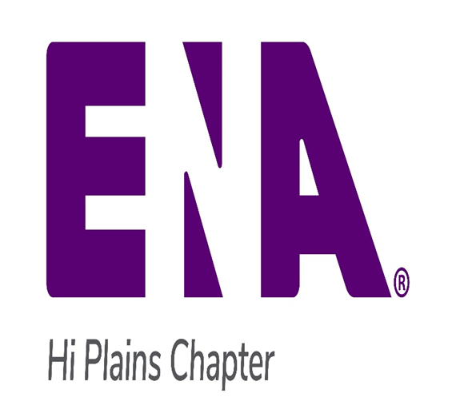

**2023 Hi Plains ENA Chapter Meetings Dates:**

*May 23*

*Location:*

*Covenant Children’s ER*

*July 20*

*Location:*

*University Medical Center ER*

*September 26*

*Location:*

*AeroCare*

*November 16*

*Location:*

Covenant Medical Center ER

**All meetings will have a virtual option. Check your email or one of the social media on meeting day for info**

2nd Q Newsletter 2023

Hi Plains ENA

Welcome!!

**Welcome**

We want to give a warm welcome to all the new members we have received this year so far.

Rotill Benson, Julia Edrington, Lexis McMinn, Cheyanne Roberson, Sarah Shinsato, Phillip Bray, Lindsey Rodkey, John Stell, Jonathon Stockin, James Ward, Kedisha Williams

We are currently at 168 members at the time of this newsletter. We are seeking to get more involvement from our members and make Hi Plains ENA a strong chapter, again!

Several social media and communication methods have been created to get member involvement up.

GroupMe <Https://groupme.com/join_group/92335907/N89PxHfg>

Facebook group: <https://www.facebook.com/groups/564718755611454/>

If anyone has any ideas for retention or wants to be more involved in our local chapter please email us at [HPENA2023@gmail.com](mailto:HPENA2023@gmail.com)

So far this year we have been able to have two in person meetings, with these meetings also being held virtual through teams. The minutes for our March meeting will be attached to this newsletter.

Page 1 Hi Plains ENA Newsletter - 2nd Quarter 2023

**Hi Plains ENA TNCC/ENPC Courses**

**TNCC Dates**

**July 20-21**

**August 24-25**

**October 23-24**

**ENPC Dates**

**September 14-15**

**\*\*All courses held at**

**Lubbock AeroCare**

**Texas ENA Meetings**

**July 14-15 Austin**

**Oct 13-14 Staked Plains Chapter**

**For more information see the TXENA**

**website at:**

[**www.txena.org**](http://www.txena.org)

**HERT class Covenant Medical Center**

**September 21st**

**Covenant Health System**

**Trauma Grand Rounds**

**September 29th (Flyer attached)**

**University Medical Center Trauma Symposium**

**October 7th (Flyer attached)**

**We still need volunteers for all of our committees that! Email** [**HPENA2023@gmail.com**](mailto:HPENA2023@gmail.com) **if interested!!!**

|  |  |
| --- | --- |
| |  | | --- | | **HOT INFORMATION**  Congratulations to Belinda Waters and  Will Stewart, who will be serving as Texas delegates  at the National ENA General Assembly  in San Diego in September.  They will review upcoming Bylaw changes  and Resolutions with members at the July meeting.  **Reminder!!!**  **We still need delegates to volunteer for state meetings also!!! Next one is in October!!**  **Practice CEN Question**  A head injury patient who presents with an injury to the middle meningeal artery is at risk of developing:  A. Epidural Hematoma  B. Facial Hematoma  C. Brain Stem Infarct  D. Subdural Hematoma | |

|  |
| --- |
| Page 3 Hi Plains ENA Newsletter- 2nd Quarter 2023 |

Answer is D. Subdural Hematoma

**Discounts**

**Being an ENA member means money saving all different things!!**

**Check out the ENA advantage page!!**

[**https://www.ena.org/membership/enaadvantage**](https://www.ena.org/membership/enaadvantage)

**There is travel discounts!!!**

Contact Us:

E-Mail: DallasCountyENA@gmail.com

Web Site: www.dcena.org

Contact us:

HPENA2023@gmail.com

1

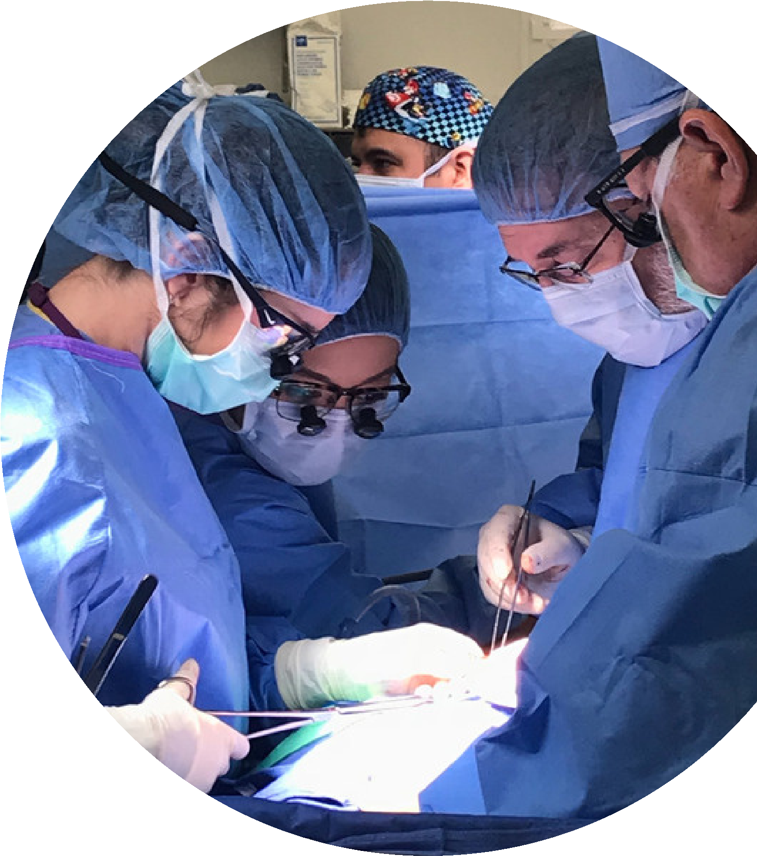

**Dr. Ari**

**Halldorsson**

**Trauma and**

**Critical Care**

**Symposium**

**Location:**

**Texas Tech University Health**

**Sciences Center -**

**Academic Classroom Building**

**th - Street Lubbock, Texas**

**3601 4**

**SATURDAY, OCTOBER 7, 2023**

**SAVE THE DATE**

To receive more information about this

symposium email

**CME@ttuhsc.edu**

**CALL FOR POSTER**

**ABSTRACTS**

**COMING SOON!!!**

**Jointly Provided by:**

Texas Tech University Health Sciences Center and University Medical Center Health System

This activity has been approved for

***AMA PRA Category 1 Credit***

***TM***

*.*



